- Network Troubleshooting, Management, Monitoring, & Optimization

Q1. Use the Windows command prompt to run the command ipconfig /all on your computer and take a screenshot of the output. Identify and write down your IPv4 address, subnet mask, default gateway, and DNS servers as shown in the result?

Answer
- Command used: ipconfig /all
- Observation:

Network Detail | Value
- IPv4 Address | 10.219.126.234
- Subnet Mask | 255.255.255.0
- Default Gateway | 10.219.126.141
- DNS Server | 10.219.126.141

- Result:
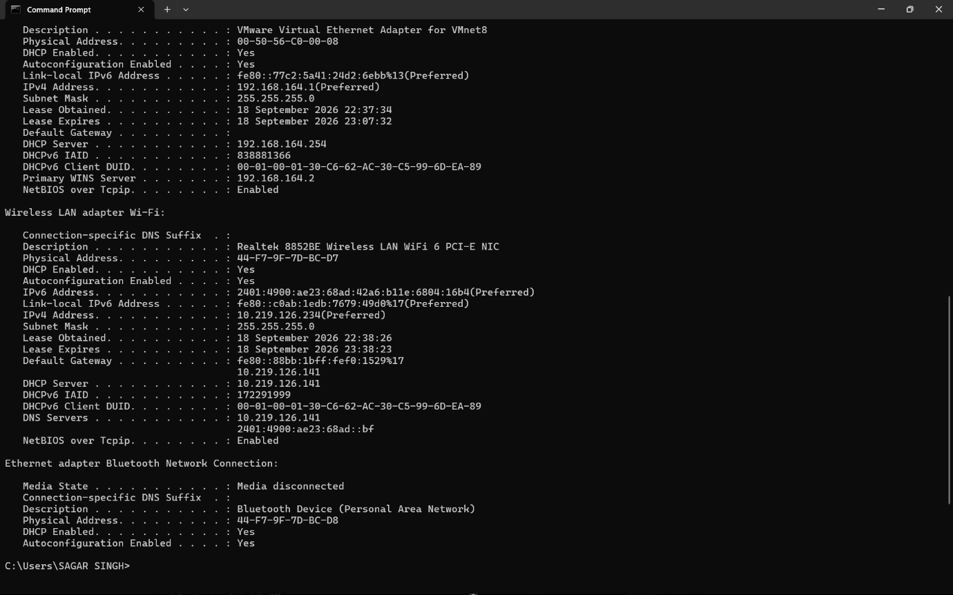
The ipconfig /all command successfully displayed the network configuration of my Wi-Fi adapter. My IPv4 address is 10.219.126.234, subnet mask is 255.255.255.0, default gateway is 10.219.126.141, and the main DNS server is 10.219.126.141.

Q2. Simulate a network connectivity issue by disconnecting your Wi-Fi or Ethernet cable, then use the ping command to check connectivity to www.google.com. Reconnect and repeat the ping. Write a short note on the difference in results and what each status means?

Answer
- Command Used: ping www.google.com
- Observation:
Network Status | Result | Meaning
- Wi-Fi Disconnected | Ping request could not find host www.google.com | The computer could not reach the DNS server or Internet, so the website name could not be resolved.
- Wi-Fi Connected | 4 replies received, 0% packet loss | The Internet connection was working and Google was reachable.

- Explanation:
When Wi-Fi was disconnected, the ping failed because the computer could not resolve or reach www.google.com. After reconnecting Wi-Fi, all four packets received replies with 0% packet loss, showing that the network connection was working properly.
- Result:
The ping command successfully demonstrated the difference between a disconnected and connected network.

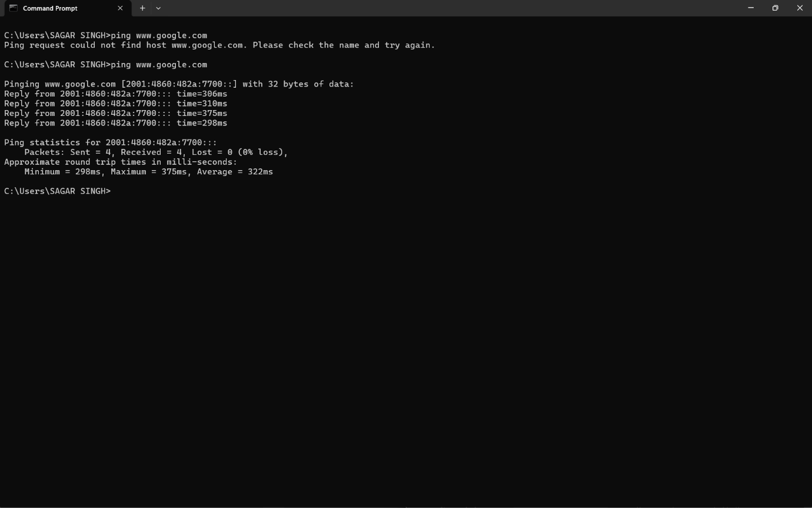

Q3. Open Task Manager or Resource Monitor on your system and monitor network usage for 5 minutes while streaming a YouTube video. Record the peak network usage value and note which process used the most bandwidth during this time?

Answer
To monitor network usage for 5 minutes while streaming a YouTube video and identify the process using the most bandwidth.
- Steps:
- Opened Task Manager / Resource Monitor.
- Played a YouTube video in Google Chrome for about 5 minutes.
- Monitored the Wi-Fi network graph.
- Opened Resource Monitor → Network.
- Checked the Processes with Network Activity section.
- Compared the Send, Receive, and Total network usage of running processes.
- Observation:
Item | Value
- Highest network speed observed | 3.7 Mbps
- Process using most bandwidth | chrome.exe
- Chrome Receive Rate | 30,290 B/sec
- Chrome Send Rate | 6,163 B/sec
- Chrome Total Rate | 36,453 B/sec

- Result:
During YouTube streaming, Google Chrome (chrome.exe) used the most network bandwidth. The highest network speed I observed during the test was approximately 3.7 Mbps.

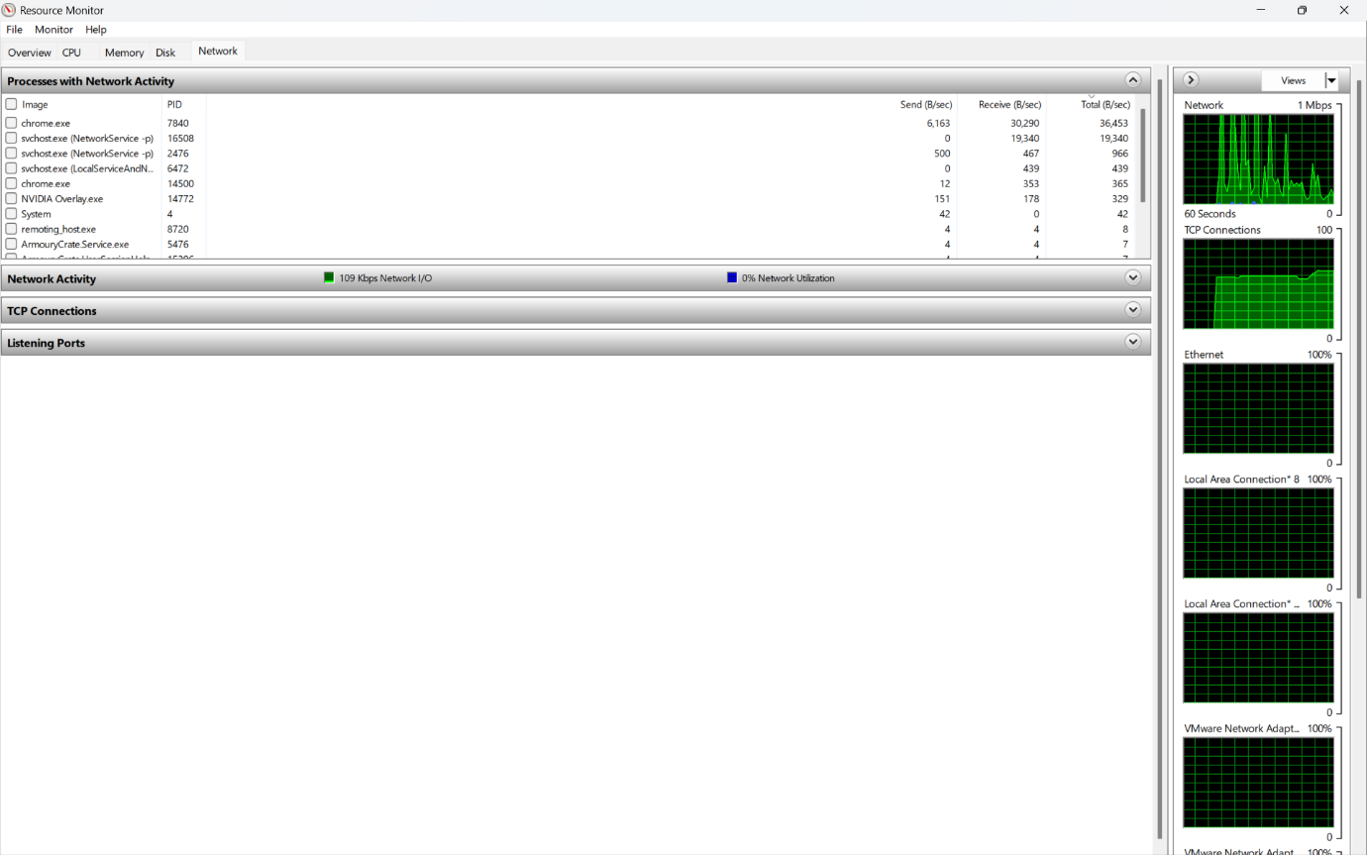
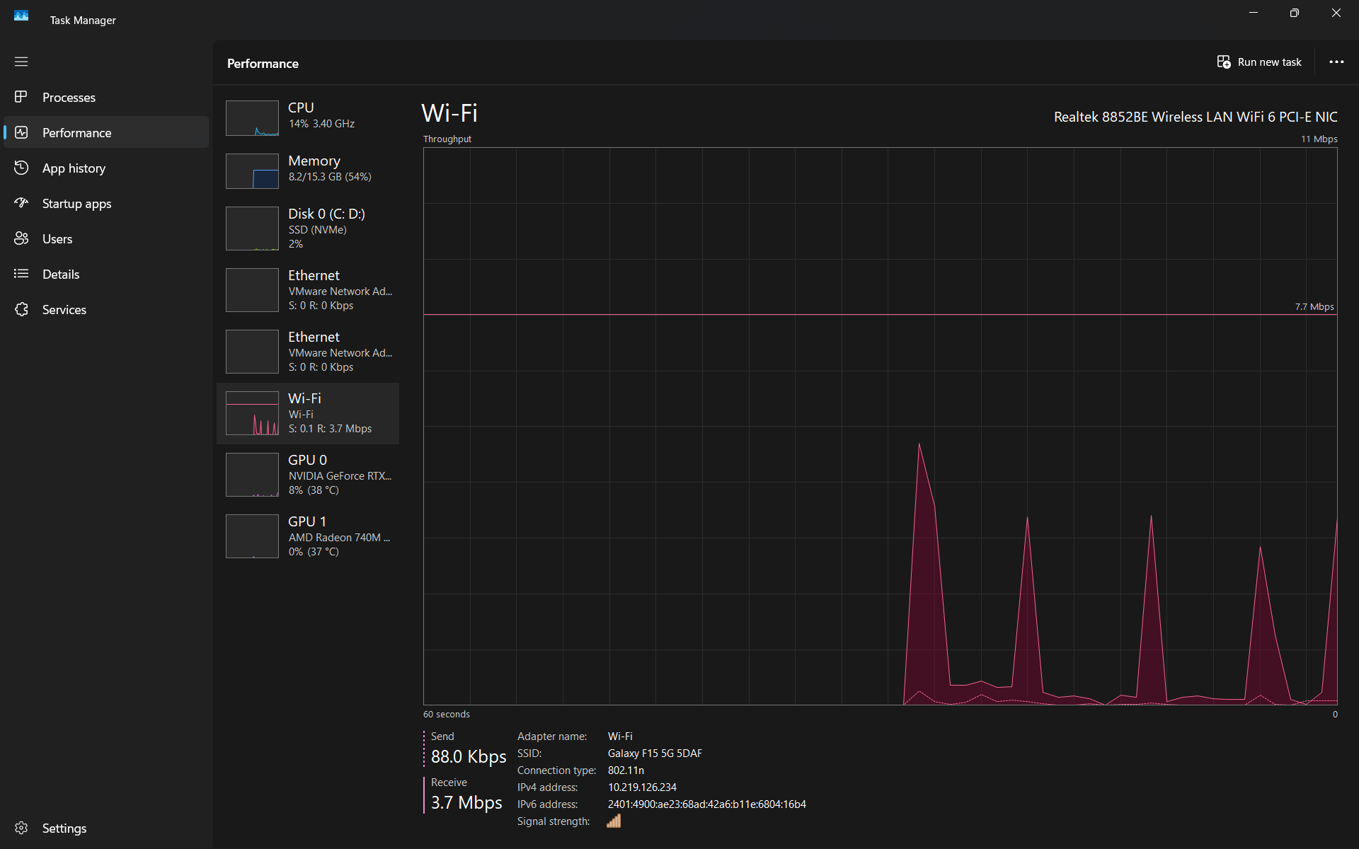

Q4. Download and install Wireshark (or use an online packet capture demo if installation is not possible). Capture at least 30 seconds of network traffic while browsing Flipkart or Instagram Web, then filter the packets to show only HTTP or HTTPS traffic. List 3 types of information you can see in these filtered packets.<br><br><em><strong>Hint:</strong> Use the filter bar in Wireshark and try http or https as the filter keyword.</em>?

Answer
To capture at least 30 seconds of network traffic while browsing a website and filter the packets to view HTTPS traffic.
- Steps:
- Opened Wireshark.
- Selected the active Wi-Fi interface.
- Started the packet capture.
- Browsed a website for at least 30 seconds.
- Stopped the packet capture.
- Entered the following filter in the Wireshark display filter bar: tls
- Pressed Enter to display HTTPS-related encrypted traffic.
- Observed TLS and QUIC packets in the capture.
- Three Types of Information Visible
- Source IP Address – shows the device or server sending the packet.
- Destination IP Address – shows where the packet is being sent.
- Protocol and Port Information – shows protocols such as TLSv1.2, TLSv1.3 and QUIC, commonly using port 443 for secure web traffic.
- Observation:
The filtered capture showed encrypted web traffic using TLS and QUIC. The packet details also displayed source and destination IP addresses, packet length, and protocol information.
- Result:
I successfully captured network traffic and filtered it to view HTTPS-related packets using Wireshark.
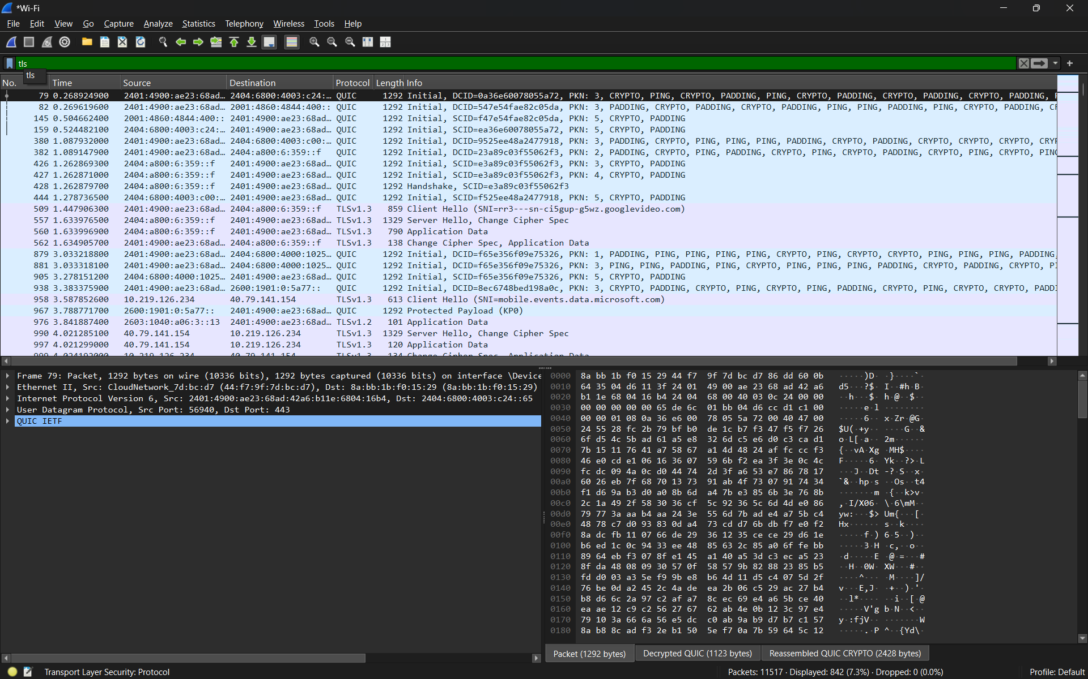

Q5. Imagine your friend is complaining about slow internet while gaming online. Use ChatGPT or any AI tool to generate a troubleshooting checklist (at least 5 points) for optimizing home network speed and reliability. Paste the AI's response and highlight one suggestion you would try first?

Answer
To create a simple checklist for improving home network speed and reliability during online gaming.
- AI-Generated Troubleshooting Checklist:
No. | Action | Purpose
1 | Restart the router and modem | Clears temporary network problems and refreshes the connection.
2 | Use Ethernet instead of Wi-Fi | Provides a more stable connection and usually lower latency.
3 | Move closer to the Wi-Fi router | Improves signal strength and reduces packet loss.
4 | Stop background downloads and streaming | Frees bandwidth for the game.
5 | Check ping and packet loss | Helps identify delay or unstable network problems.
6 | Use the 5 GHz Wi-Fi band | Can provide higher speed and less interference at shorter range.
7 | Update router firmware and network drivers | Can improve performance, stability, and security.

- Suggestion I would try first:
I would first use an Ethernet cable instead of Wi-Fi, because wired connections are usually more stable and can reduce lag while gaming.
- Conclusion:
These steps can help improve gaming performance by reducing lag, packet loss, and network interruptions.

